Task 10:
1.Date Pick:
package task10;

import org.openqa.selenium.By;
import org.openqa.selenium.WebDriver;
import org.openqa.selenium.WebElement;
import org.openqa.selenium.chrome.ChromeDriver;

public class Datepick {

public static void main(String[] args) {

WebDriver driver = new ChromeDriver();
driver.manage().window().maximize();
driver.get("https://jqueryui.com/datepicker/");
driver.switchTo().frame(driver.findElement(By.className("demo-frame")));
driver.findElement(By.xpath("//input[@id=\"datepicker\"]")).click();
driver.findElement(By.xpath("//span[text()=\"Next\"]")).click();
driver.findElement(By.xpath("//a[text()=\"22\"]")).click();

WebElement datefield = driver.findElement(By.xpath("//input[@id=\"datepicker\"]"));
String selecteddate = datefield.getAttribute("value");

System.out.println("Selected date is:" +selecteddate);
driver.quit();

}

}
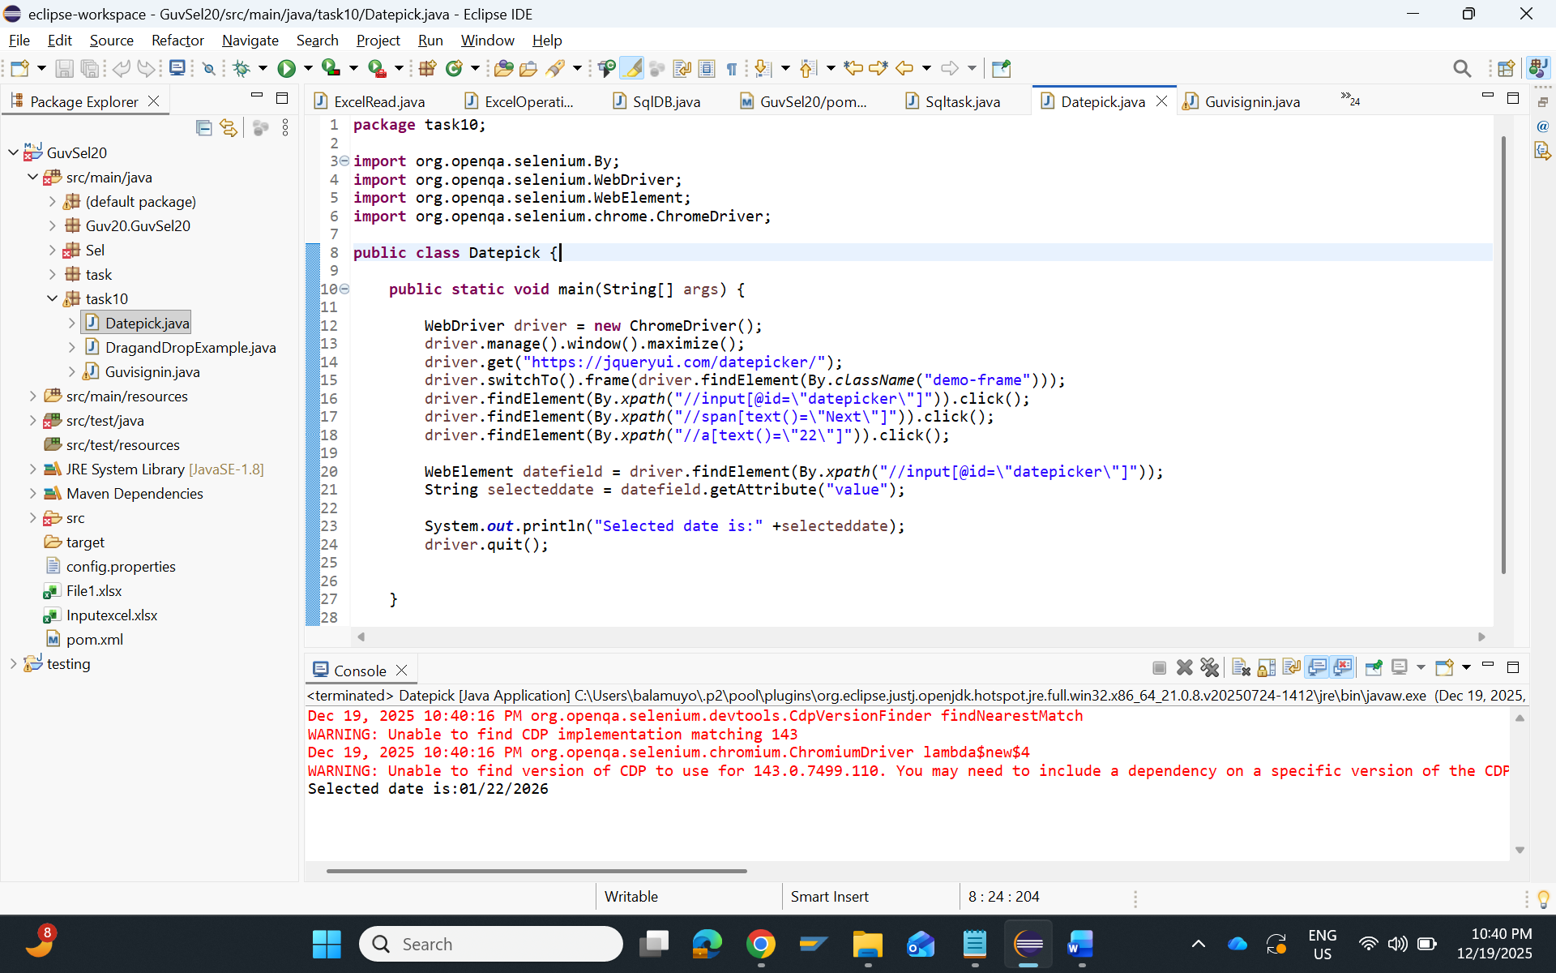

2.Drag and Drop:
package task10;

import org.openqa.selenium.By;
import org.openqa.selenium.WebDriver;
import org.openqa.selenium.WebElement;
import org.openqa.selenium.chrome.ChromeDriver;
import org.openqa.selenium.interactions.Actions;

public class DragandDropExample {

public static void main(String[] args) {

WebDriver driver = new ChromeDriver();
driver.manage().window().maximize();
driver.get("https://jqueryui.com/droppable/");
driver.switchTo().frame(driver.findElement(By.className("demo-frame")));
WebElement Source = driver.findElement(By.id("draggable"));
WebElement Destination = driver.findElement(By.id("droppable"));
Actions actions = new Actions(driver);
actions.dragAndDrop(Source, Destination).perform();

String backgroundcolour = Destination.getCssValue("background-color");
System.out.println("Background color after drop : " +backgroundcolour);

String targettext = Destination.getText();
System.out.println("Background text after drop : " +targettext);

driver.quit();

}

}
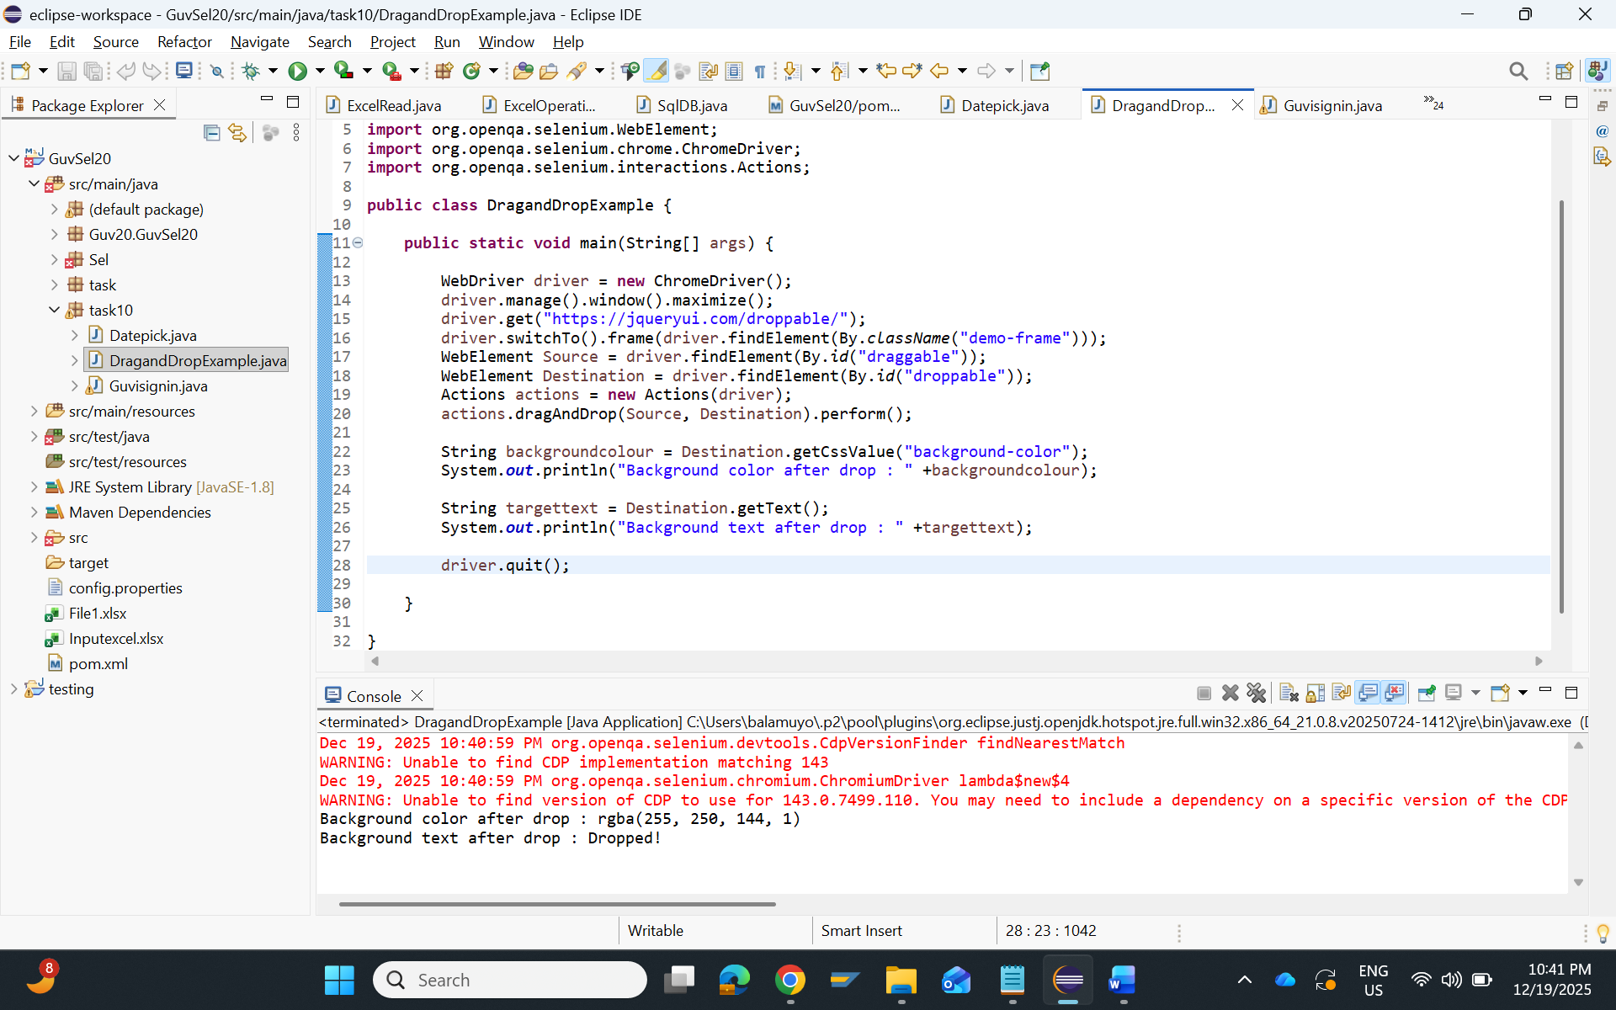
3. Guvi sign up:
package task10;

import java.time.Duration;

import org.openqa.selenium.By;
import org.openqa.selenium.WebDriver;
import org.openqa.selenium.WebElement;
import org.openqa.selenium.chrome.ChromeDriver;
import org.openqa.selenium.support.ui.ExpectedConditions;
import org.openqa.selenium.support.ui.WebDriverWait;

public class Guvisignin {

public static void main(String[] args) {

WebDriver driver = new ChromeDriver();
driver.manage().window().maximize();
driver.get("https://www.guvi.in/");
driver.findElement(By.xpath("(//button[text()='Sign up'])[1]")).click();
driver.manage().timeouts().implicitlyWait(Duration.ofSeconds(30));
WebDriverWait wait = new WebDriverWait(driver, Duration.ofSeconds(15));
wait.until(ExpectedConditions.visibilityOfElementLocated(By.id("name"))).sendKeys("Test user");
driver.findElement(By.id("email")).sendKeys("testuser199@gmail.com");
driver.findElement(By.id("password")).sendKeys("test@123");
driver.findElement(By.id("mobileNumber")).sendKeys("9003531436");
driver.findElement(By.id("signup-btn")).click();

boolean url = wait.until(ExpectedConditions.urlToBe("https://www.guvi.in/register/?sourceUri=http%3A%2F%2Fwww.guvi.in%2F"));

if(url) {
System.out.println("Signup completed succesfully");
}
else {
System.out.println("Signup failed");
}

driver.navigate().to("https://www.guvi.in/");
driver.manage().timeouts().implicitlyWait(Duration.ofSeconds(30));

driver.findElement(By.xpath("(//button[text()='Login'])[1]")).click();
wait.until(ExpectedConditions.visibilityOfElementLocated(By.id("email"))).sendKeys("testuser199@gmail.com");
driver.findElement(By.id("password")).sendKeys("Test@123");
driver.findElement(By.id("login-btn")).click();
if(url) {
System.out.println("Login completed succesfully");
}
else {
System.out.println("Login failed");
}
driver.quit();

}

}

